Creating Use Case Diagrams
Sub Title

Creating Use Case Diagrams 1
Creating the Event Table 1
Initial Use Case Diagram 2
Initial Use Case Descriptions 4
Tips for Creating Use Case Diagrams 5
Creating Use Case Diagrams in Enterprise Architect 5
Creating Use Case Diagrams 6
Creating Actors 9
Identifying Use Cases 10
Adding Associations 13

Creating Use Case Diagrams

Creating the Event Table
We now need to start thinking about some of the other diagrams for understanding the system.
The event table is a tool we shall use as a spring board to create them.
One issue when creating systems is the desire to rush ahead without really thinking about what we are doing.
This combined with the desire to get things right on the first attempt (due to fear) will mean that our systems fail to meet the requirements.
Once we have a written description of what the system will do, we may set about writing an event table.
The event table is a useful tool for thinking about who is doing what to the system.
In the event table we need to identify...
- The subject - who or what is triggering the event
- The verb – what is being done
- The object – the thing that it is being done to
- The response – what happens as an outcome of the event

To make a start on the event table we need to look at the detailed description and see what we can identify from the text...
Here is my first stab…
A customer visits the web site to buy some widgets. They have the option to add themselves as a customer to the system and edit their details. Also they are able to cancel their account on-line. Upon finding out that they are not a customer they follow the sign up process entering their details and selecting a user name and password.
On the back end of the system staff have the option to manage the data for all customers (add, edit delete) and run reports on customers.
Let’s have a think about what we have found so far.
“Visits web site”
It is very common at this stage to identify candidate events that are in fact outside the scope of the system. But, it is better to identify and reject rather than miss something important.
Don’t dismiss these candidate events completely though.
What about the following?
“Add themselves”
“Sign up”
“Entering their details”
Another issue at this point is that we might be identifying events that are in fact describing the same thing.
Let’s have a first stab in a word document...
Subject | Verb | Object | Response
Customer | Signs up to system | Sign in page | Customer details added to the system
Customer | Edits personal data | My details page | Details are updated
Customer | Cancels account | Account cancellation page | Customer is notified of account closure

Let’s keep it fairly simple at this stage as we are more interested in working through the process rather than a perfect answer.
It is clearly unfinished but it seems to be heading in the right direction.

Initial Use Case Diagram
You should already be familiar with user case diagrams in the first year. We will explore them a bit in this module but we are more interested in seeing exactly how they turn into a real world system.
Look at our initial stab at a diagram...
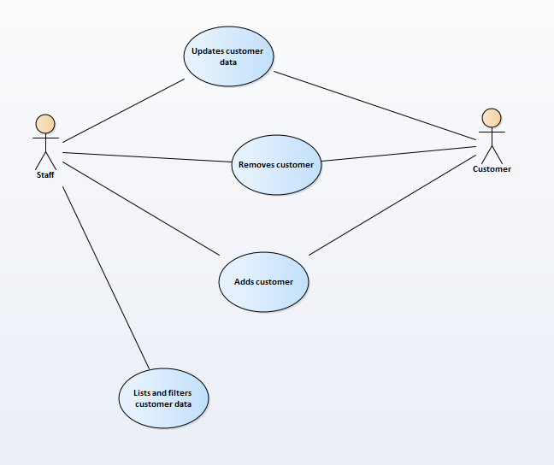
Use cases are generated from the event table.
Look at the verbs in the event tables!
Subject | Verb | Object | Response
Customer | Signs up to system (adds customer) | Sign in page | Customer details added to the system
Customer | Edits personal data | My details page | Details are updated
Customer | Cancels account | Account cancellation page | Customer is notified of account closure

Actors may be generated from the subject column
Subject | Verb | Object | Response
Customer | Signs up to system | Sign in page | Customer details added to the system
Customer | Edits personal data | My details page | Details are updated
Customer | Cancels account | Account cancellation page | Customer is notified of account closure

Initial Use Case Descriptions
The use case descriptions allow us to think more deeply about what is going on with the system
For example the use case description for list addresses might look like this.

Use Case Name (Short two or three word name) | System Sign up / Add Customer
Use Case Description (Short description) | The customer adds their details to the system via the website; they also have the option of ringing in and creating an account.
Use Case Author(s) (Who wrote this) | Jane
Actor(s) (Who does this) | Customer & staff
Locations (Where does this happen) | On-line and at the head office
Primary pathway (What is the normal “happy path” for this use case?) | User adds their details onto the system and the system accepts the data upon suitable validation
Alternate pathways (What other paths are there that are not the “happy path”?) | User adds their details only to find that the account already exists as identified by the email address.
Exception pathways (What could possibly go wrong?) | Database connection fails  Error displayed to the user advising of connection problem

Tips for Creating Use Case Diagrams
One common mistake when creating use case diagrams is to put too much in a single diagram.
Break you diagrams down into smaller diagrams of say six use cases. Use multiple diagrams with less detail.
If you want to create a top level view of the system then do so.
Remember Use Case diagrams should work for non technical users, clarity is always the key.

Creating Use Case Diagrams in Enterprise Architect
Before we get started on even thinking about writing any code we need to think about how our system is going to work.
In order to do this we are going to use the Unified Modelling Language (UML) to help us think about how our system is going to be built.
UML has a lot of diagrams we could use (13 for v2) however for this module we are only going to use four
- Use Case Diagrams
- Class Diagrams
- Sequence Diagrams
- Entity Relationship (ER) Diagrams

Each diagram will help us to think about the system from a certain view.
We could draw these diagrams by hand or we could draw them in a tool such as Word. There are however tools that are specifically designed for creating these diagrams. One such tool is Enterprise Architect.

Creating Use Case Diagrams
Right click on the view “User Model View (Presentation Layer)” and select add diagram…
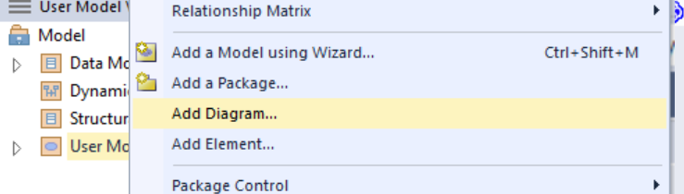
You will then be asked what sort of diagram to add…
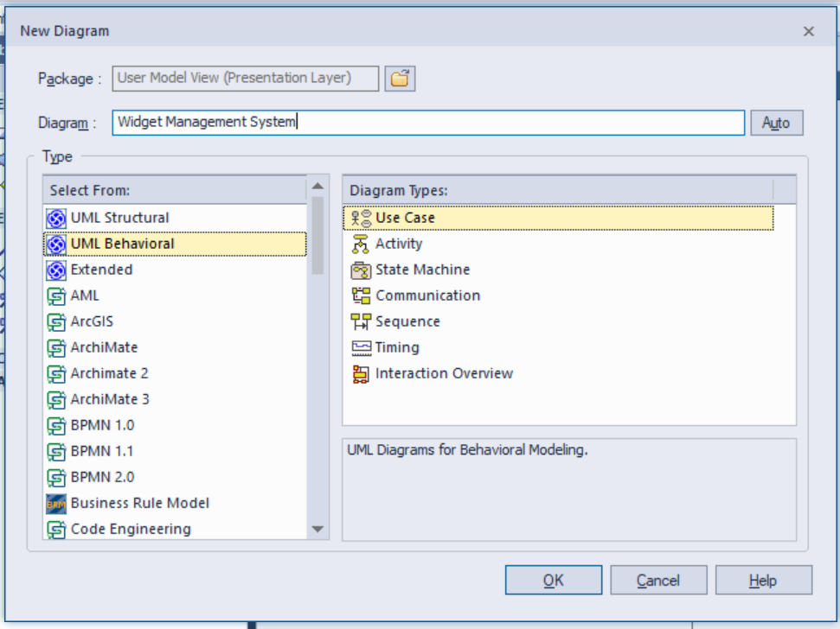
In this case select UML Behavioural diagrams I have set the name of my diagram to Widget Management System – press OK.
The blank diagram should appear in the project browser…
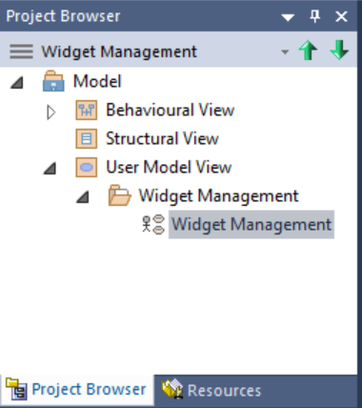
To edit the diagram double click on it and it should appear in the main part of the screen…
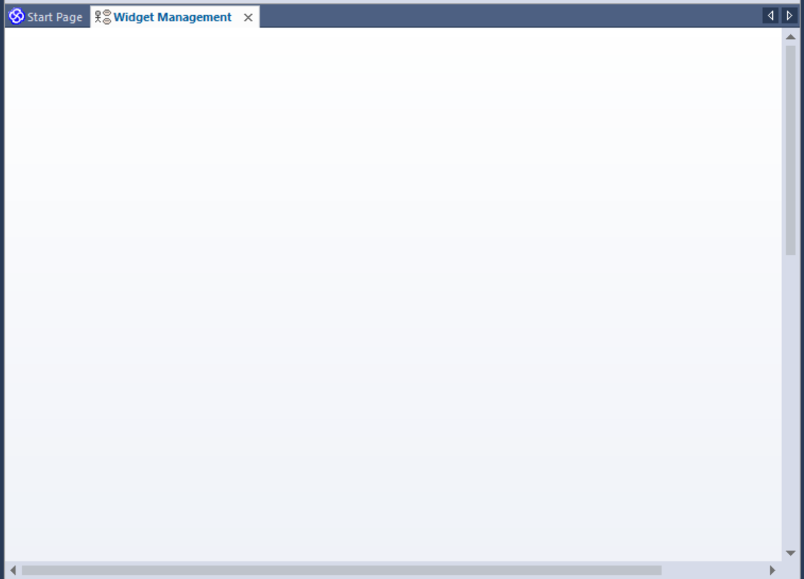
(Since we haven’t done anything yet there isn’t much to look at!)
Let’s look at the event table…
Subject | Verb | Object | Response
Staff | Adds | Widget | Data accepted by the system
System | Validates | Widget | Reports errors if there are any
System | Edits | Widget | Old data updated with now

Creating Actors
On the event table we have identified two candidate actors for the diagram…
- Staff
- System

To add the Staff actor to the diagram find the actor drawing tool in the Toolbox…
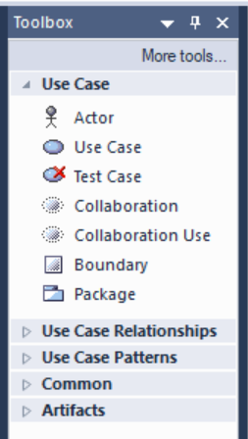
Click once on it and then click on the diagram. You should be presented with the following screen…
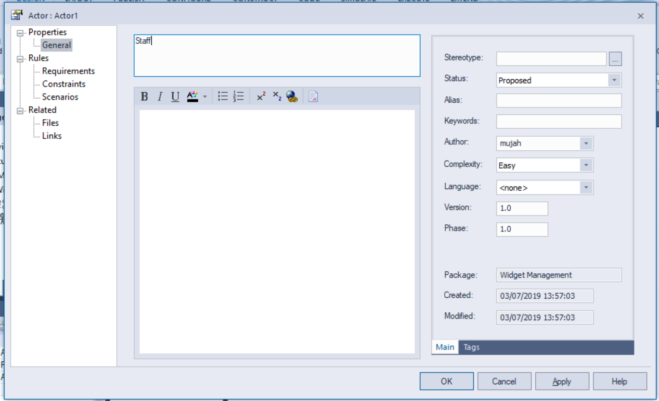
Set the name of the actor to Staff and press OK.
You should see the actor set up like so…


Identifying Use Cases
Also from the event table we get an indication of candidate use cases…
Subject | Verb | Object | Response
Staff | Adds | Widget | Data accepted by the system
System | Validates | Widget | Reports errors if there are any
System | Edits | Widget | Old data updated with now

- Adds
- Validates
- Edits

Adding use cases is a similar process to adding actors.
Click on use case in the toolbox and click on the diagram
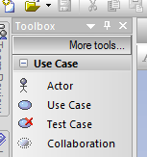
Name the use case “Add Widget”
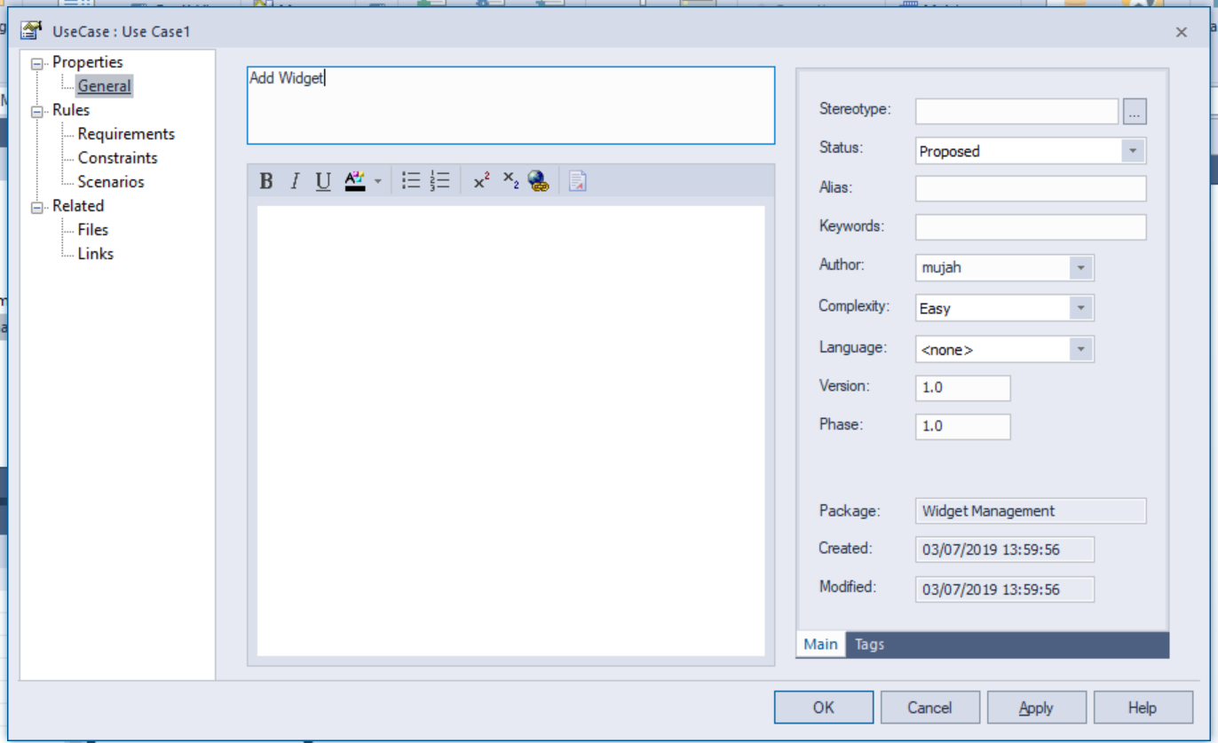
Create the other actor and use cases for the diagram such that it looks something like this…
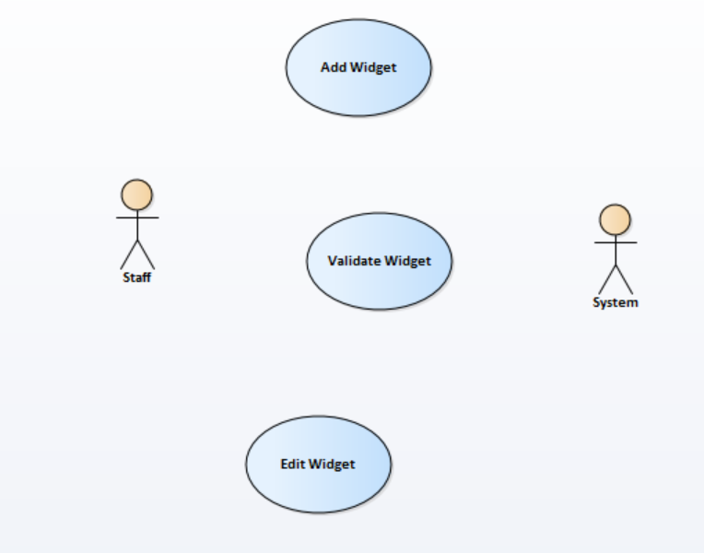

Adding Associations
Now that we have the basics of the diagram set up we need to indicate how the different elements are linked by associating them.
To add a simple association from the toolbox click on the associate tool…
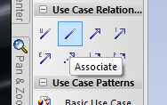
Next draw on the diagram from the source to the destination…
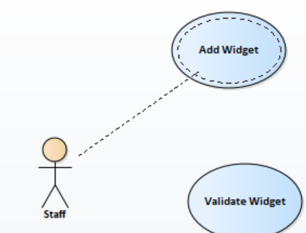
This will draw a basic association between the two…
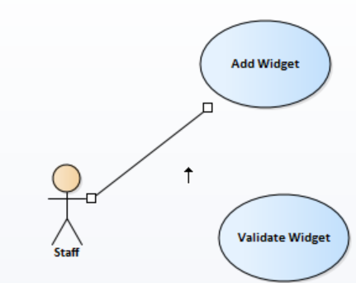
To specify the direction of the initiation double click the association and change the direction…
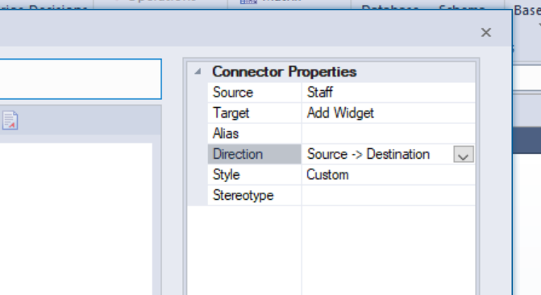
Complete the diagram such that it looks like this…
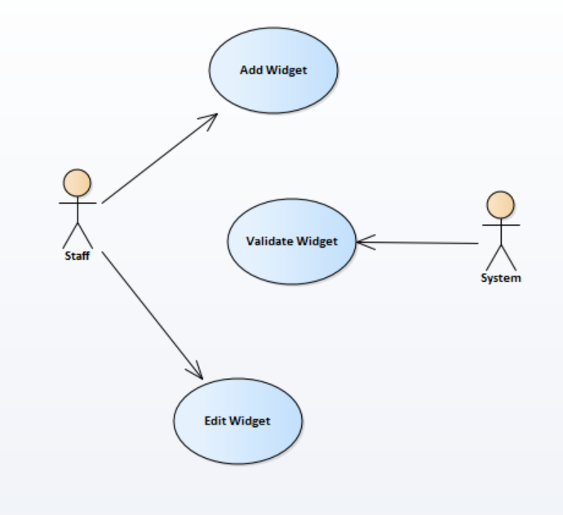
In this example we shall add an “includes” relationship.
What we want to say is that “Add Widget” always includes “Validate Widget”.
To do this select an include relationship…
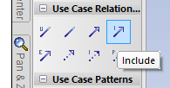
Draw it between source and destination making sure to get it the right way round…
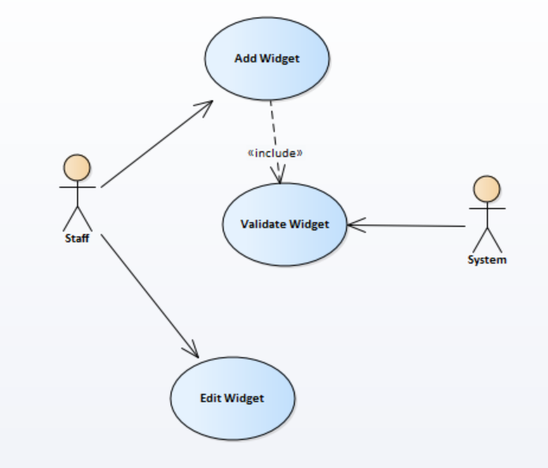
An include relationship indicates that one use case always takes place in conjunction with another one.

